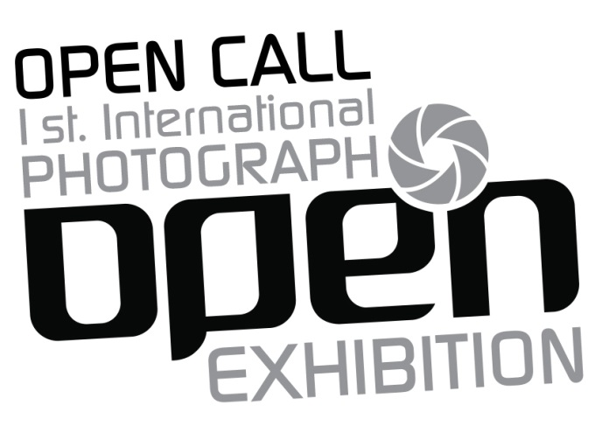

Photography is the art and technique of obtaining lasting images due to the action of light, from the first photographic process in the 1820s to the present we can see great changes in this field as well as many different ways in which photographers and visual artists approach this medium.

OPEN Center for the Arts presents this call for our first international exhibition of photography

OPEN CALL

Theme

Open theme, technique and Open to color or b/w
Up to three images for consideration, only one will be selected

Requirements

1. Must be 18 and over
2. Works must be owned by the author
3. Selected photo must be framed in a 16 x 20 inches (no exceptions)

Submission

The following MUST be completed and emailed in a Word document format with confirmation of payment to info@opencenterforthearts.org

1. Write on the subject: "OPEN Photo Exhibition"
2. Complete the registration form (attached)
3. Make registration payment through PayPal
3. Attached image of each photograph for consideration. (300dpi)
4. Name each JPG image with first initial, last name and image number (example: ASmith1.jpg)
5. In the body of the email include:
● Artist
● Photo of Artist
● Titles of works
● Type of photograph (digital or analog)
● Artist statement (no more than 100 words)

NOTE: Any incomplete registration will not be considered

Cost of registration:

A non-refundable $25 fee is required

Submission deadline: February 20, 2015.
Exhibition Date: March: 7 - April 11, 2015

Selected Artists

● We will send an e-mail to the selected artists notifying their acceptance on February 23, 2015. The list of all participants will be subsequently posted on our Facebook page and website:
https://www.facebook.com/OPENcenterforthearts
www.opencenterforthearts.org
● The selected works must be sent to the gallery framed in a 16 x 20 inches and ready for mount.
● Artists residing outside the US write to info@opencenterforthearts.com for mounting options.

Deadline for art work: February 23 - February 27
Return of art work date: May 1 - May 8

Important information

● The artist is responsible for delivering the art work ready for mounting in the framed format requested.
● The art work not picked up after 30 days from the date stipulated for this is considered donation to the gallery.
● The artist is responsible for send/return shipping cost
● The artist must complete and sign Registration Form 2015 and Liability Waiver 2015

